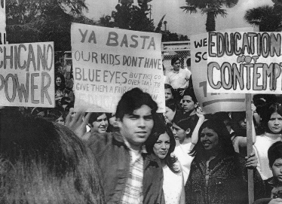
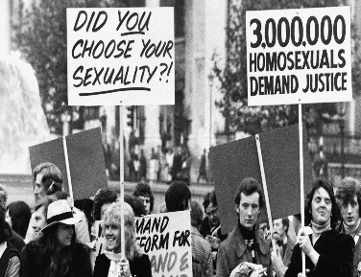
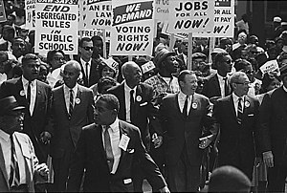
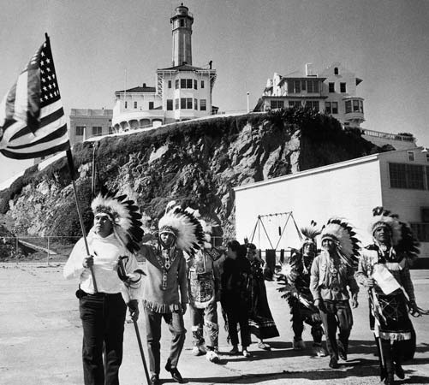
Theme 2:
The Quest for
Civil Rights

Quick Start: Re-order the following events chronologically by numbering them.

- Plessey vs Ferguson
- Freedom Rides
- Montgomery Bus Boycott
- Foundation of the NAACP
- Occupation of Alcatraz Island by AIM
- Black Americans shift their voting allegiance from Republican to Democrat
- Little Rock High School Incident
- Greensboro Sit in
- Executive order 8802 banning discrimination in the armed forces
- The Kerner Report
- Brown vs Topeka Board of Education
- ‘To Secure these Rights’
- The height of KKK membership
- SNCC expels white members
- The Indian Self-Determination and Education Assistance Act
- Stonewall riots

Challenge:
- Add the date for each event
- Write a short sentence to explain why each was a significant turning point for civil rights.
Theme 2: The quest for civil rights, 1917–80
In studying Theme 2 you have considered the struggle for minority rights in the years 1917–80, with particular reference to African-American civil rights. You have learned about the political, social and economic situation for black Americans across the period, and are aware of the changing nature and pattern of campaigning; you should be able to identify relevant examples. You should gain knowledge of major federal civil rights legislation and an understanding of their impact. You should be aware of the influence of the black American struggle on the search for non-black-American minority rights, but also understand the distinct reasons for campaigning by other minorities.
Mark each on a scale of 1-5
1= very confident / sufficient / effective – 5 = Never heard of it / action needed!
Theme and topic: |  | How confident am I? | I have  sufficient  notes on this topic. | I have given evidence of my wider reading for this topic. | I have sufficient revision materials for this topic. | I have started to revisit and consolidate this topic during independent study. | I have completed practice essays for  this topic. | Actions needed and taken  (list details)
Theme 2: The quest for civil rights, 1917–80

Black American civil rights, c1917–55 | Life in the South and  The impact of northern migration, 1917–32
The impact of the
New deal, the second world war and the Truman
Presidency
 | From legal challenge to direct action, 1917–55.
Black American civil rights, c1955–80 | Changing patterns and approaches, 1955–68, including southern-based  Campaigning, the emergence of black power and king’s  Northern strategy
The impact of civil rights legislation:
Achievements and limits to success, 1955–80
The search for minority rights, 1960–80 | Reasons for, and  Nature of, native American and Hispanic American  Campaigns
 | The emergence of the gay rights movement
 | The achievements, and limits to success, of minority campaigns.

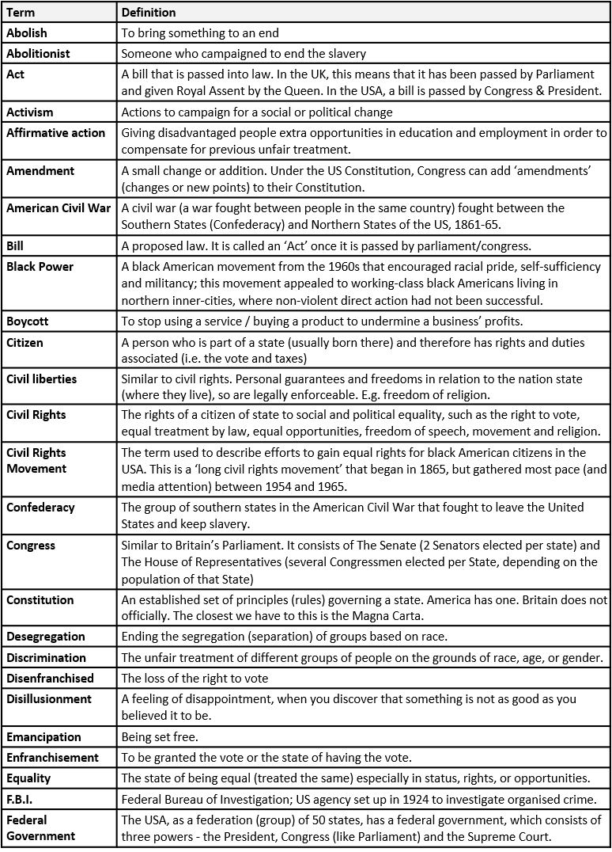
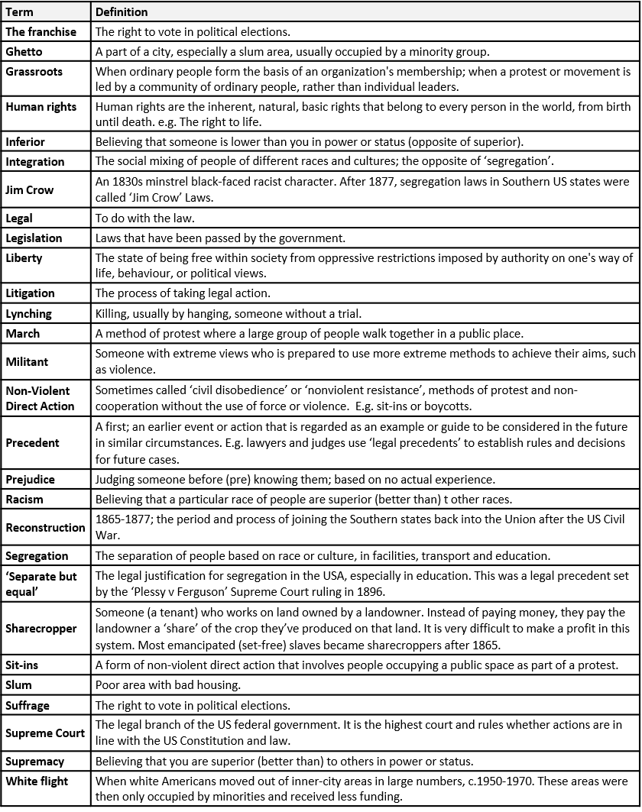
Y8 Term 3b: Civil Rights in the USA - Key Words

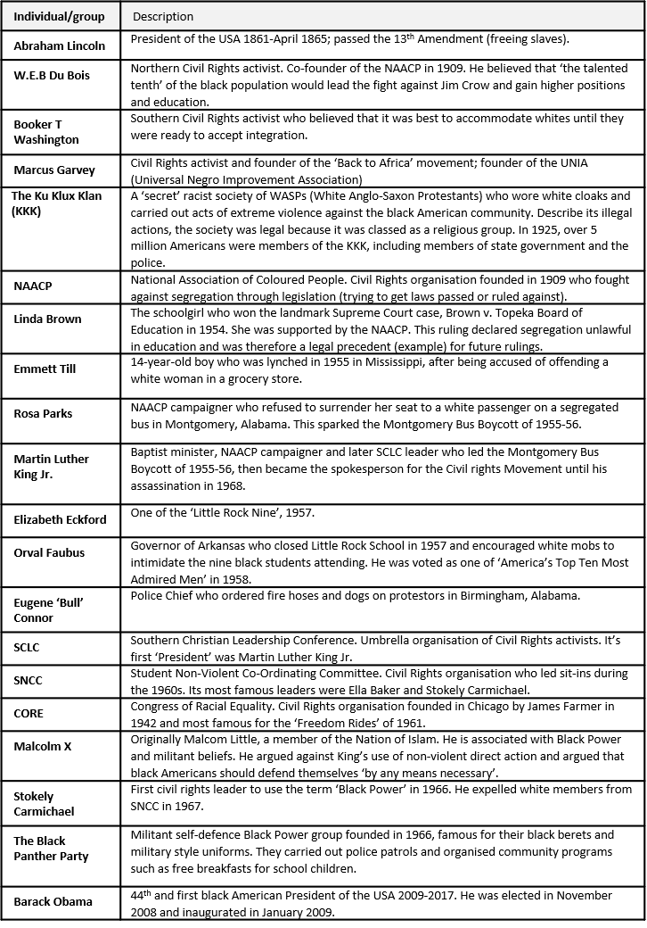
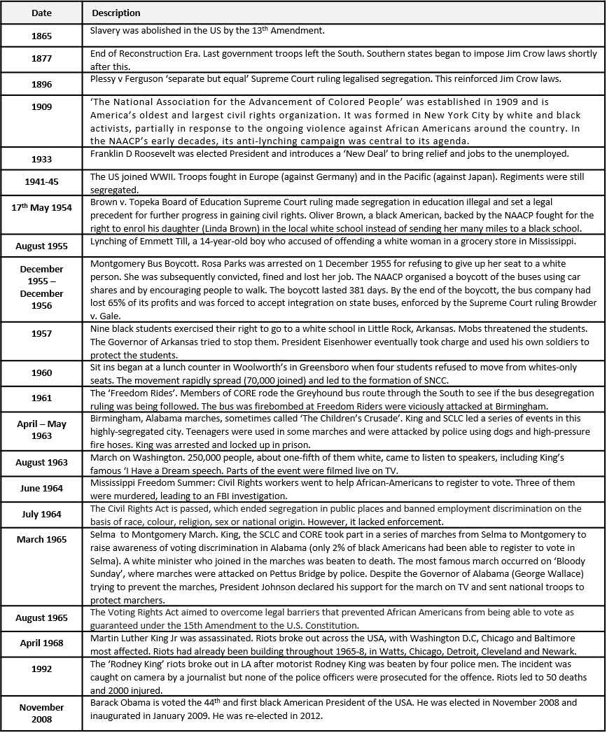
Y8 Term 3b: Civil Rights in the USA – Individuals, groups and dates

Which way forward?
There is a common misconception (misunderstanding of history) that ‘The Civil Rights Movement’ began in the 1950s and 1960s, led by infamous figures such as Martin Luther King Jr and Rosa Parks. This suggests that little efforts were made by black Americans to resist and overcome the Jim Crow Laws that segregated and discriminated against them before the 1950s. This, of course, if not true. In fact, the roots of the movements in the 1950s and 1960s originated in the individuals and community movements that began in the 1890s, at the height of Jim Crow segregation violence. The community-based activism (activities to fight against segregation) can be called ‘grassroots’ activism. This means that large numbers of black American communities built organisations to fight racism in their local areas. However, these groups and the individuals who led them differed tremendously in their aims and tactics.
Church organisations – Community-based activism
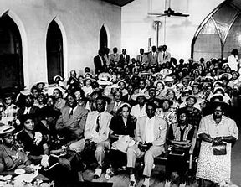
Black American churches were the centre of most black Southern communities. Protests against racism were often led by and rallied around the Church. The Church provided the physical space people needed to meet to organise their protests. However, this also made them the target for violent attacks by the KKK.
The Church also provided the leadership for protest. Black clergymen (such as Martin Luther King Jr) were often community leaders and organisers, as well as spiritual leaders. They became effective in leading protests because:
- They were paid by the Church, so could not lose their job if they spoke out against racism.
- They were well-educated and effective speakers
- Their high status and authority in the black community meant that the white community had to listen to and negotiate with them
- They had a large network of contacts, so could organise mass protests
- They could gain the support of whole communities, black people of all ages and classes.
White people had conflicting attitudes towards the Church. Some white Southerners approved of the Church’s protests because they urged Christian values and non-violence. Black clergymen were also well-educated and polite, so white people thought they would be easier to meet with and make false promises of future reform. However, many white Southerners were scared of black American church groups. Black churches provided an organisation that could be used to organise not just social events, celebrations, and clubs, but also political protests. Black churchmen had authority in their communities and so could be very effective at calling black Americans to action in protest.
Booker T. Washington – Practical education and accommodation
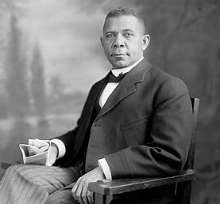
Washington is now a controversial figure. At the time, however, he gained wide support amongst Southern black Americans, who saw his tactics as pragmatic (realistic). He argued that white people in the South would not accept black American success any time soon and would always react with violence to supress it. He therefore said that black Americans should not try to educate themselves academically (intellectual subjects, reading and writing)and gain equality; there was little point in doing this because white people would never accept it in the Jim Crow South.
Instead, he said, black Americans should educate themselves in practical skills and impress white Americans in the jobs that they were allowed to do: domestic servants and labourers (low-skilled jobs). He said, “there is as much dignity in tilling a field as there is in writing a poem”.
In 1881, he set up the Tuskegee Institute, a segregated black school for practical education in farming and domestic work. Washington is often called an ‘accommodationist’, accommodating (allowing, accepting) white racism rather than fighting against it. Many people think that Booker T. Washington reinforced the stereotype that black Americans were not as clever as white people and suited only to low-skilled jobs.
W.E.B. DuBois – Academic education
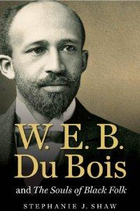
DuBois lived in the North where there was less segregation, but discrimination was an everyday occurrence for black Americans. He directly disagreed with Booker T. Washington, writing many books and speeches as a direct rebuttal to Washington’s arguments.
DuBois argued that black Americans should educate themselves as much as possible to disprove racist stereotyping. He argued that black Americans needed to fight against racism, rather than work within it, and that an educated black elite (the ‘talented tenth’) should lead black people in the US and in Africa to freedom and equality. He said that Washington was ‘accommodating’ (allowing) racism and asking black Americans to sacrifice their dignity and civil rights for the sake of economic gain, making money.
DuBois was very well educated and head of History and Economics at Atlanta University. In 1900, he set up the ‘Niagara Movement’ which worked to fight racism in politics, publish newspapers that would give black Americans a voice and organise educated black Americans to lead organisations. In 1909, DuBois and other activists set up the NAACP. He also became editor of the NAACP’s newspaper, The Crisis.
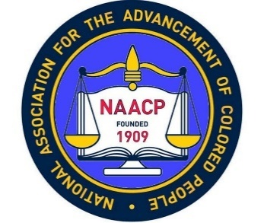
The NAACP – Litigation and Grassroots community activism
The NAACP’s (the National Association for the Advancement of Coloured People) main strategy was the use of litigation, which meant fighting racism and segregation (specifically the Plessy vs. Ferguson ruling) on a legal basis in US courts. The NAACP also organised grassroots organisations in black communities. By the early 1920s, it had over 90,000 members and 274 branches. This meant that there were now local groups dedicated to gaining legal equality.
The NAACP organised an anti-lynching campaign, led by a journalist called Ida B. Wells-Barnett. By 1918, at least 3,224 black Americans had been murdered in the USA by lynching. The real figure is almost certainly a lot higher. She published numerous books, pamphlets and articles about lynching and became known for her passionate and articulate (well-communicated) writing. In the early 1930s, she proposed anti-lynching bill (law) that would demand trials for any police officers that failed to investigate lynching properly. She gained mass support for the bill. Unfortunately, it was not passed by the US Congress into law. Although the NAACP was unsuccessful in securing anti-lynching legislation, the NAACP’s nationwide and interracial (black and white) support meant that the number of lynchings did decline.
The NAACP’s membership was not considered a mass organisation until the 1940s. Many black Americans saw the NAACP as elitist. Most black American’s main priorities were securing a job and having enough money to live on, so politics and legal rights did not seem relevant.
In the 1930s, Walter White became the leader of the NAACP. He began to focus on economic justice and pay for black Americans, which seemed more relevant to black Americans. He was close friends with the US President’s wife, Eleanor Roosevelt, which gave him political influence. He also challenged unequal funding in education, employing a talented lawyer called Thurgood Marshall. Marshall won several cases that guaranteed equality in higher education and gave black American teachers equal salaries. In 1940, the NAACP set up a Legal Defence Fund. This was a fund to help wrongly-convicted black Americans fight against their convictions in court.

Marcus Garvey – Black Nationalism
Marcus Garvey was a nationalist who promoted black pride amongst the community. He had come to the USA from Jamaica in 1916 and he set up the UNIA, the Universal Negro Improvement Association. He also set up the African Orthodox Church, with black images of God and the holy family.
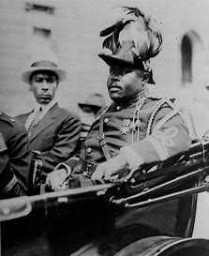
Garvey moved to Harlem in New York where UNIA thrived. Garvey was an impressive speaker and embarked on a speaking tour throughout the USA. He urged black Americans to be proud of their race and return to Africa, their ancestral homeland and attracted thousands of supporters. Despite being very poor, his supporters donated at least 10 million dollars to his cause. He established the Black Star Line, a shipping company that would transport black Americans to Liberia in Africa. However, the ships were not seaworthy and in 1923 Garvey was arrested for fraud. He was sent back to Jamaica in 1927 and the UNIA fell apart without him. He died in 1940. In 1964, his body was returned to Jamaica where he was declared the country's first national hero.
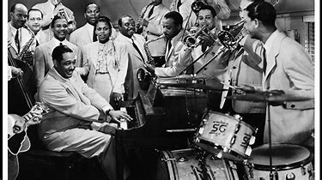
The Harlem Movement – Cultural pride
Harlem became a centre for black culture and pride during the 1920s and 30s. Black Americans write musicals and jazz and wrote poems and novels. Real black actors played black people in films; before this, black people had been played by white people with black make up! White people came to Harlem’s jazz clubs to hear Duke Ellington play or Ella Fitzgerald sing.
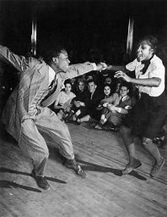
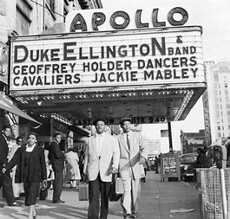
For the first time, in Harlem, some white people realised that black people could do things as well as, if not better than, white people, disproving racial stereotypes.

Black Americans in the New Deal Era

The impact of the GD on black Americans | Unskilled black Americans were ‘last hired’ and therefore …. |  | Between four to six times higher
 | How much higher was the black unemployment rate than white Americans? |  | 30-60%
 | Urban black unemployment ranged from…. |  | ‘last fired’
The First and Second New Deals | The % of Americans unemployed by 1932… |  | Reform
 | The 3Rs of the New Deal were ‘Relief, Recovery and….’? |  | The ‘brain trust’
 | In his first 100 days, Roosevelt, as well as passing the Economy, Emergency Banking and Beer Acts, be employed a staff of experts to enforce legislation called… |  | Social security reform
 | In his first 100 days, Roosevelt introduced government agencies better known as …. |  | 25%
 | His First New Deal was largely aimed at dealing with the immediate problems of the Depression –. |  | relief, recovery and reform
 | The Second New Deal was aimed at improving the lives of ordinary people through…. |  | Alphabet agencies
The Brain Trust | In 1933, Roosevelt employed this liberal white Southerner as his ‘Special Adviser on the Economic Status of the Negro’ |  | Robert Weaver
 | The latter was succeeded by his black assistant… |  | Harry Hopkins
 | Roosevelt’s Secretary of the Interior 1933-46 was ….., a progressive Republican. He was a reporter, lawyer and Chicago politician, and also President of the Chicago branch of the NAACP. |  | Clark Foreman
 | An architect of the New Deal programmes and specifically supervised FERA, NYA and WPA. |  | Harold Ickes
- The name of the report published by Truman’s committee of liberals in 1946 (‘political suicide’). It recommended anti-lynching legislation, abolishing the poll tax, creating voting rights laws and ending discrimination in interstate travel, the armed forces and employment. |  | The SC gave no date by which schools should be desegregated and said nothing about de facto segregation (by 1964 less than 3% of black children were attending desegregated schools).
- The difference between Northern and Southern segregation. |  | The Fair Employment Board (federal hiring quotas) and desegregating the army.
- Two pieces of legislation passed through Congress by Truman in 1948 and 1951. Neither were very successful but advertised presidential commitment to equality. |  | To Secure these Rights
- The main strategy of the NAACP alongside other protests. |  | De Jure (in law) and De facto (in fact, if not in law).
- The leading NAACP lawyer who fought the Brown case. |  | Litigation, to erode Plessy v Ferguson 1896
- Two problems with the SC’s Brown ruling in 1954 and Brown II’s ruling in 1955. |  | In America’s top ten most admired men
- The name of the liberal Chief Justice of the Supreme Court under Eisenhower (who later said that this nomination was the ‘biggest damn fool mistake’ he’d ever made). |  | 50,000 to 200,000
- The number of black students prevented from entering Little Rock High, Sept. 1957. |  | non-violent direct action
- What Orval Faubus was voted by a public opinion poll in 1958 |  | Eisenhower
- The name of the president who intervened at Little Rock |  | Nine
- Increased NAACP membership during WWII |  | Thurgood Marshall
- The new NAACP tactic, having realised that litigation no longer worked. |  | Earl Warren
Black Americans in the post-WWII Era

Black Americans from c.1955

TASK: Name the black civil rights event from 1955.

Begins in December 1955 (organised by NAACP) in protest over segregation in transportation. It resulted in a 65% profit loss for this industry, forcing integration to be accepted. This was enforced by the Supreme Court in Browder v Gayle (1956).

Nine black students were attacked by angry mobs who threatened, abused and spat at the students as they tried to attend a white school in 1957. The state governor tried to prevent their attendance until Eisenhower stepped in and used national troops to protect the students.

Began in 1960 with four students who refused to move from white-only seats at a Woolworths lunch counter in Greensboro, Alabama.

Members of CORE rode the Greyhound bus through mainly Southern states to test enforcement of desegregation laws on public transport.

MLK and the SCLC led a series of events in this highly-segregated city in 1963. Teenagers were used in some marches and were attacked by police using dogs and high-pressure fire hoses. The event was highly publicised and shocked the nation.

In August 1963, 250,000 people (about one fifth of them white) protested and listened to speakers, such as King’s ‘I have a dream’ speech.

In June 1964, CORE & SNCC organised a voter registration drive in Mississippi. They were met with racist violence from the KKK and three were murdered leading to an FBI investigation.

In July 1964, this legislation was passed, ending segregation in public spaces and banning employment discrimination based on race, religion, sex or national origin.

Protest held in March 1965 led by MLK, the SCLC and CORE to raise awareness for voting discrimination in Alabama. Protesters were met with violence and attacked by police, but LBJ declared his support and sent national troops to protect protesters.

In August 1965, this legislation prohibited discrimination in voting and led to a dramatic increase in black voters.

In April 1968, large-scale riots broke out across the US after this significant event, with D.C., Chicago & Baltimore most affected. Prior to this, riots had already been building throughout the North between 1965-8.
Black Americans by c.1980

TASK: Finish the sentences to summarise black civil rights by c.1980.
- Presidential Executive orders to promote ___________ _________​.
- Growth of ________ culture in the Inner Cities.
- 45% of black children lived below the _________ line compared to 16% of whites​.
- A black upper and middle ________ began to emerge in the cities.
- 1 in 5 black males spent part of their lives in ___________. ​
- __________ number of Black graduates.
- The poorest got _________ with 30% of Black Americans living in poverty by 1990.
- Increased Black representation in the higher levels of business, elected office and the _____________. ​
- Increase in the percentage of Blacks registered to _______​.
- ________ as likely to be poor as White Americans​.
- Increased black representation in ________, TV and music. ​
- Black ________ ownership increased​.
- In 1990 the median black _________ was $24,000 for whites it was $40,100.

What were the similarities and differences between the civil rights campaigns of black Americans and other minority groups?
- Aims?
- Tactics?
- CR Leaders?
- Events
- Government
- Success?

Practice Essay Questions
How far do you agree that it was the actions of civil rights leaders that lead to the success of the civil rights campaign, 1954-65? [20]
- Decide what factors you might use in this question.
- Come up with at least two examples that you could use for each factor (detail not needed, yet).

How far do you agree that the opportunities provided by war facilitated the greatest improvements in the lives of black Americans between 1917-45? [20]
- Decide what factors you might use in this question.
- Come up with at least two examples that you could use for each factor (detail not needed, yet).

Edexcel A-Level History
Papers 1 and 3 – establishing and using criteria

On the mark schemes for all the new Edexcel A-Level papers, there is a requirement to establish and use criteria in your judgements. This just means showing the examiner how you can measure the extent of something.

But this is not hard to do - it simply means being clear about the reasons for the judgements you make!

Here are some thoughts for how you can do this on Papers 1 and 3…….

Change/Continuity, Significance, and Similarity/Difference criteria (to judge the extent)
* Amount of people affected – consider social class, geographical spread, age and gender
* Length of change or impact – short or long term?
* Deep difference or lots of progress compared to previous situation – e.g. in attitudes or policies
* Speed or pace – happened quickly or slowly over time?
* Effectiveness – accepted or resisted?
* Level of threat to the status quo

Consequence criteria (to judge the most significant consequence)
* Speed or pace – effects happened quickly or slowly over time?
* Effectiveness – accepted or resisted? Achieved aims?
* Coherence/consistency – stayed the same or adapted?
* Lead to or connected to other effects

Causation criteria (to judge the most significant cause)
* Connections to other causes
* Presence in a range of factors
* Level of threat to the status quo
* Trigger – present for a short time, but without it the event or change may not have happened when it did
* Underlying – present for a long time and created the conditions for an event or change to happen

The criteria you use will depend on the conceptual focus of the questions and the topic focus

Don’t overdo it – keep to around 3 criteria for any one question

For some questions, you could structure your answer around the criteria

In reaching a judgement, you should also evaluate the relative significance of criteria – for example in judging the extent of change you might conclude that something which affects all social classes is more significant than something that lasts a long time (or vice versa!)

Model Answer
How far do you agree that it was the actions of civil rights leaders that lead to the success of the civil rights campaign, 1954-65? [20]
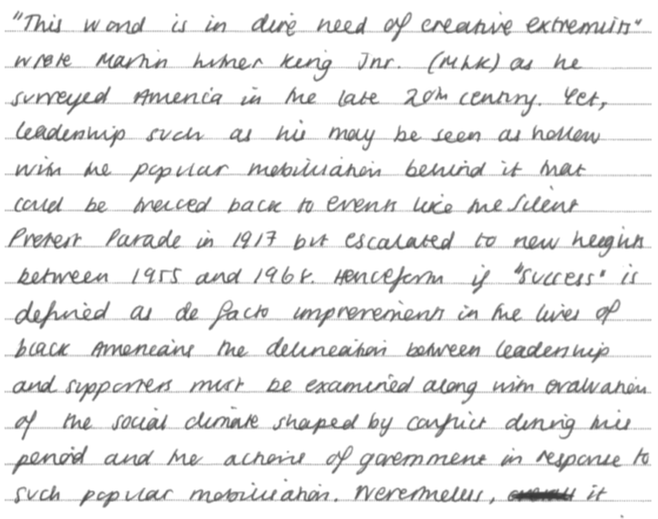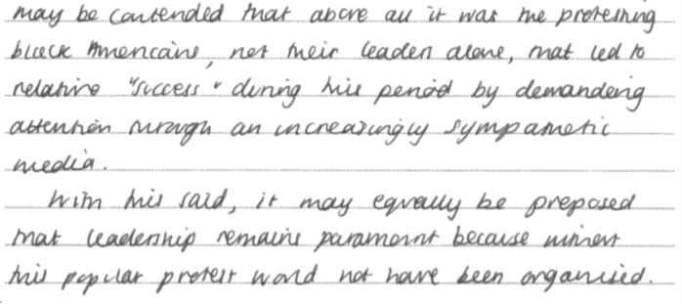
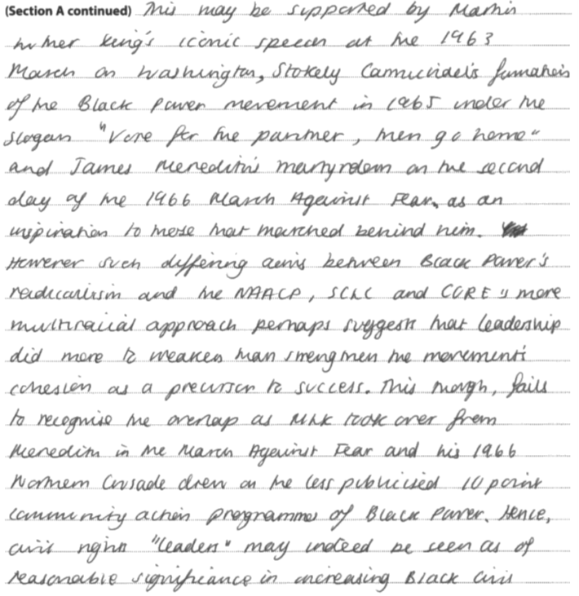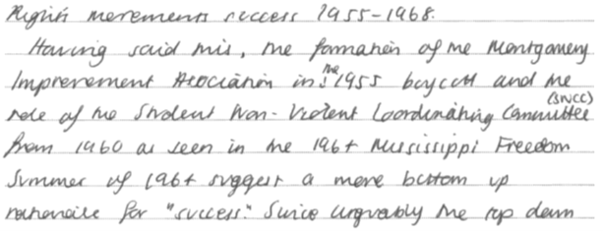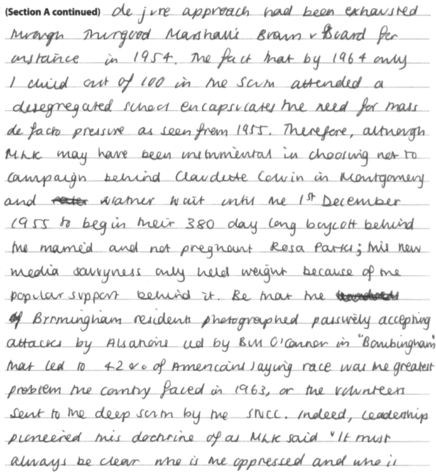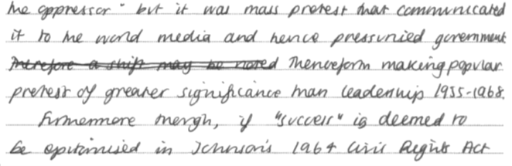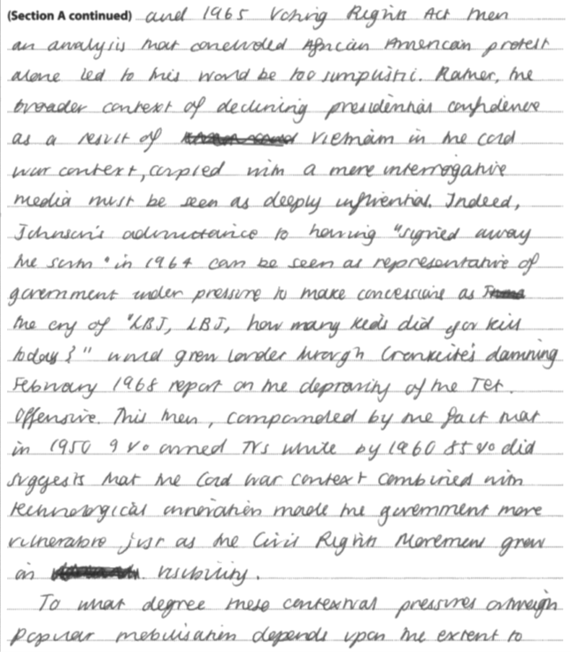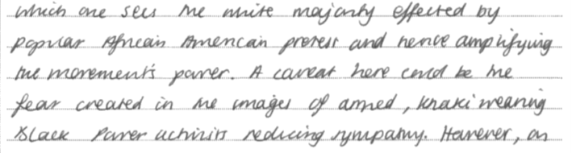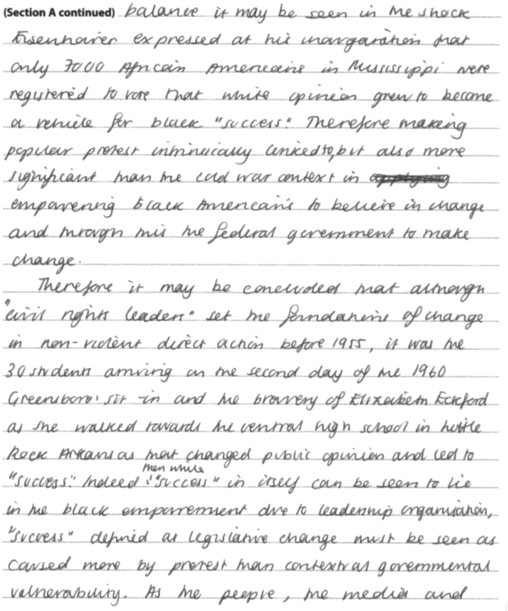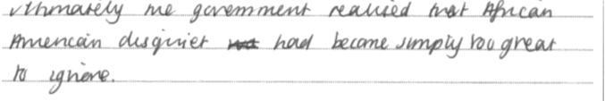
Examiner comment:
This response demonstrates many of the qualities of a level 5 essay. The answer is clearly organised and focused, with a firm grasp of what the question is asking. The candidate is able to offer a range and depth of specific knowledge, and apply this to examine the role played by leaders, and explores this relative to other factors, and so sustains argument and analysis. The argument is logical and reasoned, and the candidate produces a well-developed judgement. Development is coherent and lucid, showing a firm grasp of both the period, and the demands of this particular question.
Practice Essays

Section 1.2 The quest for civil rights, 1917-80
- Was the media the main reason for the increasing sympathy for the civil rights movement in the early 1960s? (20) AS Section A, Pearson textbook page 50
- How accurate is it to say that it was the actions of civil rights leaders that explain the increased success of the civil rights campaign in the years 1955–68? June 2017 A Level Paper
- How far do you agree that the aims and methods of black American civil rights activists in the years 1955–68 were radically different from those of activists in the years 1917–55? Sample Assessment Material
- Was the shift of tactics by the civil rights movement in the 1940s and 1950s the main reason for the passing of the Civil Rights Act in 1964? (20) AS Section A, Pearson textbook page 140
- How far do you agree that the impact of Northern migration (1917-32) can only be considered in terms of the migrants themselves and the cities they moved to? (20) AS Section B, Pearson textbook page 40
- How far had legal action advanced the position of black Americans between 1917 and 1955? (20) AL Section A, Pearson textbook page 45
- To what extent did Hispanic Americans draw on the tactics and resources of black Americans in their struggle for civil rights? (20) AL Section B, Pearson textbook page 58
- How far do you agree that there was a considerable similarity between the campaigns for black civil rights (1955-80) and minority civil rights (1960-80)? June 2018 A Level

Other questions not yet used in SAMs or past papers:
- To what extent did Native Americans draw on the tactics and resources of Black Americans in their struggle for Civil Rights?
- To what extent did Gay Americans draw on the tactics and resources of Black Americans in their struggle for Civil Rights?
- Was the actions of Martin Luther King the main reason for increasing support for the Civil Rights Movement in the 1960’s?
- How far do you agree that Black Americans had made significant gains in their fight for civil rights by 1980?
- How far do you agree that Hispanics had made significant gains in their fight for civil rights by 1980?
- How far do you agree that Native Americans had made significant gains in their fight for civil rights by 1980?
- How accurate is it to say that minority rights campaigns achieved considerable success in the years 1960–80?

